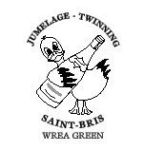

General Knowledge Quiz

Friday 18th October 2013

7.30pm at the School Hall

Ticket £4, includes a glass of wine on arrival

FOR TICKETS, PLEASE CONTACT
MIKE PARKER (683700) MIKE COCKRILL (672799)
